Polska Szkoła Sobotnia im.Adama Mickiewicza w Blackburn
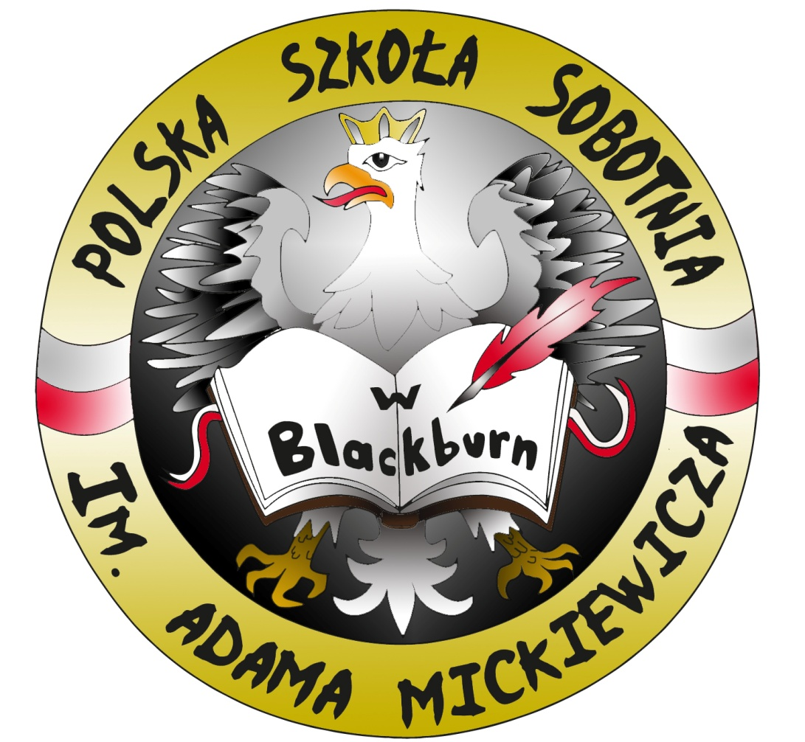LOGO SZKOŁY, JEŚLI TAKOWE POSIADA
Polish Saturday School Blackburn
Rok Założenia / Established: 1950
11 Preston New Road, Blackburn, BB2 1AR
GDPR – Polish Saturday School Blackburn
PRIVACY STATEMENT

What is a Privacy Statement?
A Privacy Statement explains what information we hold about you, why we hold it, how we protect it for you, and how you can have your information removed from our records if you so wish. Here at the Polish Saturday School Blackburn we take your privacy seriously and will only use your personal information to administer your registration / account and to provide the products and services you have requested from us.

Why are we sending you this information?
A new law - the General Data Protection Regulation (GDPR) - comes into effect on 25 May 2018 and affects the way charities, as well as companies and other organisations, keep information about their supporters. That is why we are sending you a summary of our updated Privacy Statement.

What information do we hold about you and why?
The information we hold about you could include information you give us when you fill in forms, subscribe to our services (such as newsletters, or to attend events) or respond to email updates.
This information is important to us, because it enables us to send you news of the School and its work and let you know how you can support us and how we can support you. We predominantly contact you by email and may also do it by post or text message (sms), where you have given permission.

With who is your personal information shared?
We may share your personal information with our partners and partner organisations who carry out work on our behalf - for example, suppliers who process our printed material, process information about events, or updates about running our organisation.

How long do we keep your information?
We keep information for as long as we need it for the purposes for which it was collected. This will vary depending on the type of information. If you opt-out from the School-related communications we will keep your information to ensure we don't inadvertently contact you about it in the future. This will be reveiewed annually.

What are our responsibilities and your rights?
We always take exceptional care with the information we hold about our pupils and parents and School staff. Where we contact you by email, SMS or other electronic means, we do this with your consent.
We hope that you find the information provided by the school useful and up to date. However, you have the right to ask us not to use your personal information – in this is the case please contact the School Director at polskaszkola.blackburn@gmail.com
Please be aware that if you opt out, you will not receive any school updates information.
You also have the right to see copies of information held about you. For details on how to do this, please write to the School Director. You can contact him by writing to the email address above.
Finally, please be assured that we will under no circumstances sell or share your personal data with any commercial third party.

If you agree to us contacting you electronically please confirm that you are giving us your active consent as per declaration below.
I [imię i nazwisko] ……………………………………………….. hereby agree to the Polish Saturday School Blackburn using my personal information in accordance with the statement above.
I confirm that I have read and understood the contents of this document.

Ja, niżej podpisany …………………………….......................... wyrażam zgodę na przetwarzanie moich danych osobowych przez Polska Szkoła Sobotnia im.Adama Mickiewicza w Blackburn, zgodnie z powyższym Privacy Statement.
Jednocześnie potwierdzam, że przeczytałem i zrozumiałem treść powyższego dokumentu.

Signature / Podpis: ..................................................................
Date/ Data: …………………………………………………………

